PROGRAMMING SPTT-2510
- Install the SPTT-2510 USB driver and make sure the port on the PC shows like below:
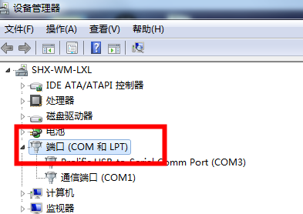
- Connect the walkie talkie and PC with a micro-USB cable, the micro-USB port is on the right side of the walkie talkie.
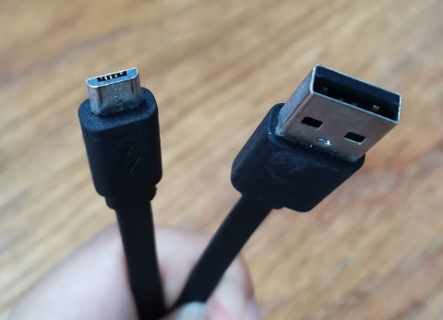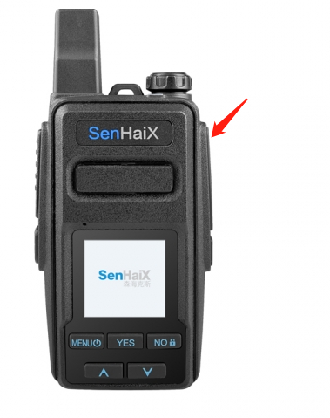
- Power on the walkie talkie, open the software, choose “REAL PTT” and press “read”, the device will be connected successfully.
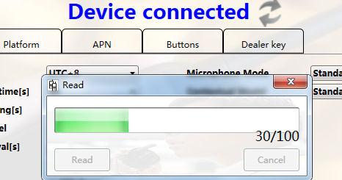
- Input your accounts, password and URL and press” write”, that’s all. If the walie talkie still can’t communicate, please contact Real PTT or us, sometimes VPN information is needed.

Ps. If you are using your own micro-USB cable, you are advised to cut the plastic so the jack can be plugged in well.
